Driven Racing Oil™ Improves Popular Break-in Oil
Olive Branch, MS – Leading lubricant engineer Driven Racing Oil™ has re-formulated its popular BR Break-In Oil to provide even better protection than the original.
Customers may notice the 15W-50 weight oil’s lighter color, which Driven attributes to the additive package and detergent changes made as a result of testing in conjunction with Total Seal. The improved formula offers more than 30 percent better protection than the original version developed 12 years ago.
“Because Driven constantly looks for ways to improve our products, we do update formulas from time to time,” Certified Lubrication Specialist Lake Speed Jr. said. “This newest formula provides increased ring seal for better vacuum, less blow-by and more horsepower.”
Comparison testing showed the improved formula reduced the camshaft wear rate by 3.56 microns/hr during a traditional 30-minute break-in period, based on Adcole precision measurements.
Driven’s conventional BR Break-In Oil is recommended by multiple camshaft manufacturers. It contains optimum levels of Zinc and Phosphorous for maximum protection on flat tappet camshafts and lifters and the added film protection needed on aggressive roller valve trains during initial break-in, as well as promotes ring seal.
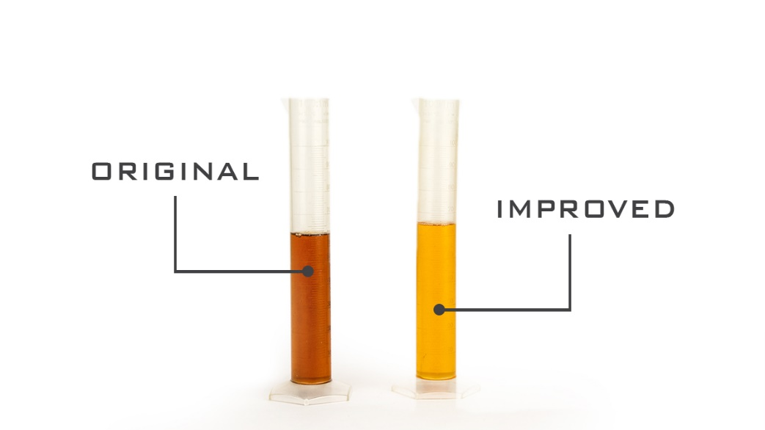

About Driven Racing Oil™
Driven Racing Oil™ utilizes cutting-edge lubricant technology and on-track research for maximum performance gains from all of its product offerings. Competition drives innovation, and Joe Gibbs Racing originally developed the Driven brand of oils to advance engine and driveline performance on the racetrack. From full-synthetic race oils to engine break-in oils and cleaners, Driven offers a wide range of race and street products that deliver performance, protection and value.

